Support School Name
Our Fundraiser Goal:

Fundraiser Dates: ____/____/____-____/____/____

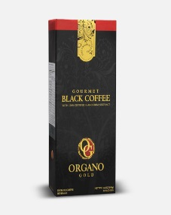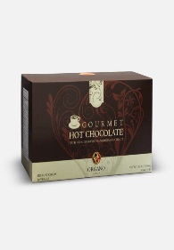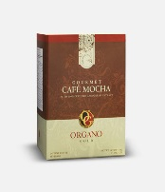

Gourmet Black Coffee Gourmet Hot Chocolate Gourmet Cafe' Mocha
$30 Box (30 Servings) $30 Box (15 Servings) $30 Box (15 Servings)

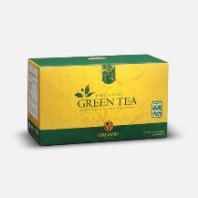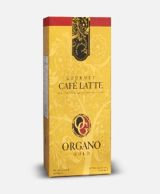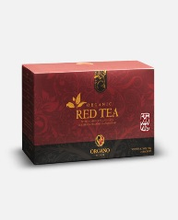

Organic Green Tea Gourmet Cafe' Latte Organic Red Tea
$30 Box (25 Servings) $30 Box (20 Servings) $30 Box (25 Servings)

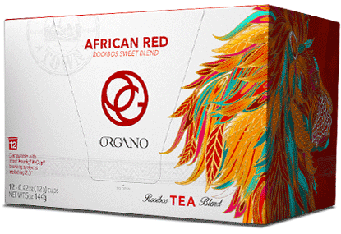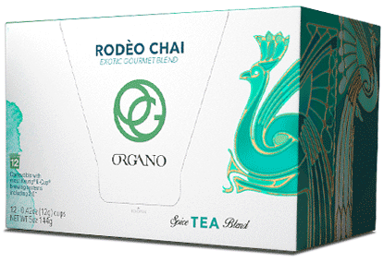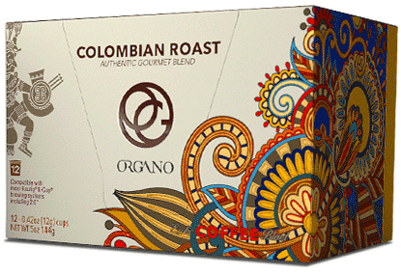

African Red Tea Rodeo Chai Tea Columbian Roast Coffee $30 Box (12 Servings) $30 Box (20 Servings) $30 Box (25 Servings)

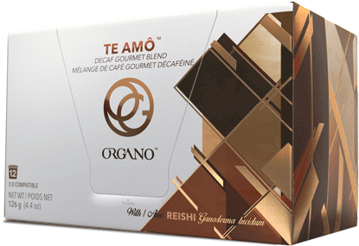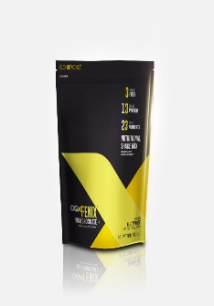

Te Amo Decaf OGX Chocolate Shake Mix OGX Vanilla Shake Mix $30 Box (12 Servings) $60 Bag (30 Servings) $60 Bag (30 Servings)

